

**TABLE OF CONTENTS**

1. **General**

1.1 Hardware

1.2 Using FN EXPERT***TM*** device

1. **Training Examples**

2.1 Field training

2.2 Marksmanship training

1. **Application Software**

3.1 Start up

3.2 User interface

3.3 Field training

3.4 Marksmanship training

3.5 Additional features

1. **Additional information**

4.1 Targets and precision

4.2 Multiple Shooters

4.3 Monitor training

4.4 Service and disposal

1. **Live Fire Training**
2. **Getting help**
3. **FN EXPERT *TM* Illustration Figure List**



# General

The FN EXPERT ***TM*** is an optical multi-functional training device for enhancing shooting skills. It can be used indoors or outdoors with scaled-down targets and at simulated shooting distances, or with life-size targets at real shooting distances. It measures rifle movement, detects the shot, shows the location of both hits and misses, and provides instant analyses of the shooter’s performance. It can be mounted onto most rifles, either to the barrel with an adapter or to a Picatinny rail.

Flexible and adapitable the FN EXPERT ***TM*** is fully portable and can provide training anywhere at anytime. The FN EXPERT ***TM*** device operates in a stand-alone mode or in a connected mode either wired or wirless to a Windows based computer. In the stand-alone or connected mode the FN EXPERT ***TM*** provides the ability to engague targets at real or simulated distances. It has the unique ability to adapt to single or multiple; ring or silhouette targets. These targets may be passive or active. The targets may be at a known distance or at a shooting distance not known beforehand which greatly enhances opportunities for training. This unique scaleability alows training to be more realistic in any space available.

* **Can be Used Dry-Fire, Simulated Recoil (CO2), Blanks and Live Fire**
* **Can be Used Indoors, Outdoors, On Range and in Lanes**
* **Portable, Small Form Factor, No External Wiring/Infrastructure**
* **Uses Assigned Weapon (not a toy/simulation)**
* **Supports Weapon with all Optics and Accessories**

FN EXPERT ***TM*** device is used for shooter training both indoors and outdoors; in a dry or live fire mode. A typical FN EXPERT System, consistes of EXPERT Optical device, a Windows Computer with EXPERT application software installed and a target that has a reflective surface or has a prism(s) attached. Bluetooth is the preferred means of connectivity between the computer and the FN Expert, although the system can be tethered (by USB cable) to workstation.

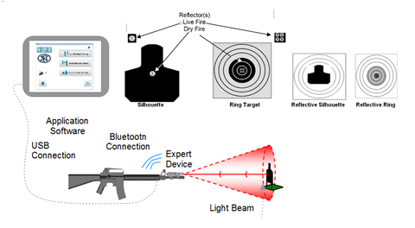

FN EXPERT ***TM*** Training System (Figure 1.1)

The FN EXPERT ***TM*** System is extremely user friendly. It is ruggedly constructed for both indoor and outdoor use. The system is easy to set up and ready to use in minutes.

### 1.1 Hardware

### 1.1.1 Parts of EXPERT device

The FN EXPERT ***TM*** Basic System consists of the FN EXPERT ***TM*** Software, Optical Unit, Plasticized 25m target, Plasticized 10m zero target¸, micro USB cable, USB charging wall adapter, 3mm hex wrench and a three-year warrantee.

Optical unit consists of Optical Measurement Part (OMP, in front) and User Interface Part (UIP), which includes main electronic board, rechargeable battery, buttons, buzzer, USB connector and graphic display, and built-in Bluetooth module.

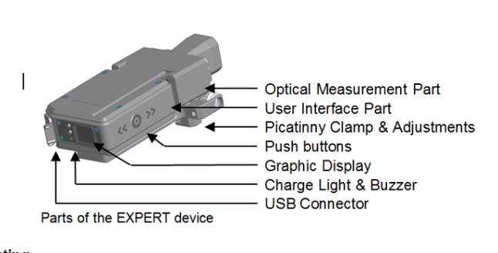(Figure 1.2)

### 1.1.2 Mounting

The FN EXPERT ***TM*** Optical Device may be mounted to a Picatinny rail or to an optional barrel adapter clamp. Generally the FN EXPERT ***TM*** Device is mounted above the barrel of the rifle (Default Position). Mounting the FN EXPERT ***TM*** device to the Picatinny rail is done using a 3 mm hex wrench (Allen key). Please note, that stability of some Picatinny rails on a weapon might not be adequate for training purposes. For mounting the device to the barrel, different sizes of optional barrel adapter clamps are available. Mount the clamp to the barrel of the rifle. Mounting the FN EXPERT ***TM*** device to the barrel is done using a hex wrench . The hex wrench is located under the device and fits to all screws found on the device and on the optional barrel adapter(s). Mount the Optical device to the barrel adapter using the Picatinny rain on the device.

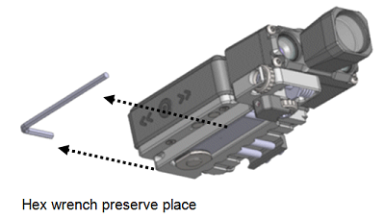(Figure 1.3)

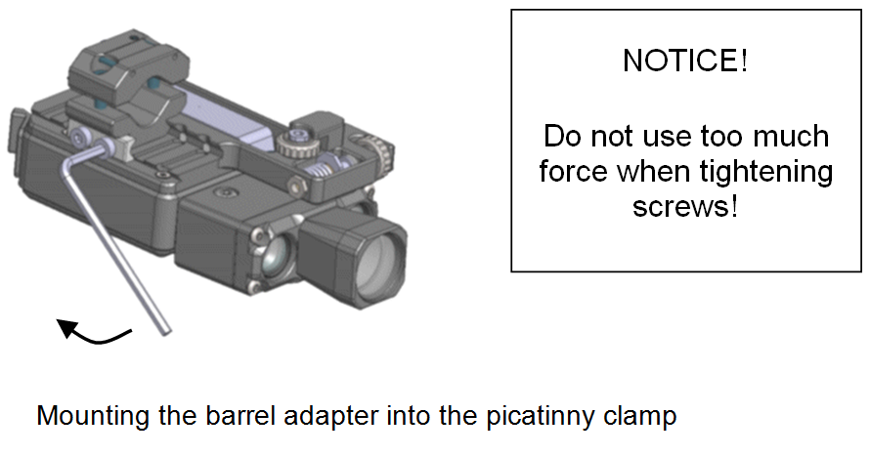(Figure 1.4)

Remember to put the hex wrench back after use in order to avoid losing it.

If needed, the Picatinny clamp on the optical device can be adapted for 5 different fixing positions 10 mm apart.

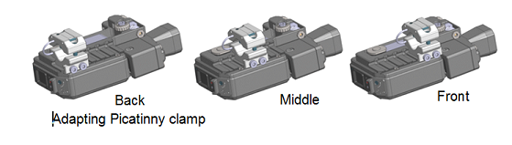(Figure 1.5)

The figure below shows mounting the device to the barrel in the **default mounting position**. Do not tighten the screws too much.

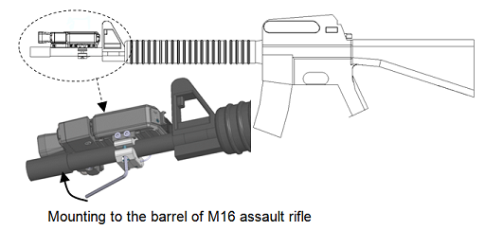(Figure 1.6)

In addition, the device can be mounted in four different positions on the weapon.

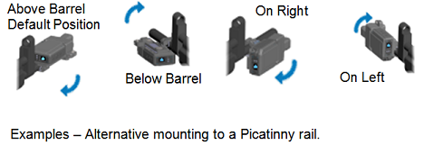(Figure 1.7)

When the device is mounted in other than, the default position, on the top of the barrel, the device has to be set up using the application program (Application Chapter 3).

### 1.1.3 Zeroing

Zeroing is mechanical, except when connected to a PC wireless or wired. Mechanical zeroing can be done stand-alone with any reflective target at any distance. If there are several targets at different distances, zero to the farthest target,. Mechanical zeroing must be accomplished each time the FN EXPERT ***TM*** Device is installed to a weapon or if target distance is changed . When used in stand-alone mode, using three push buttons operates it: “Main” button and two arrow buttons. Pressing the “Main” push button for one second turns on the FN EXPERT ***TM*** device. When the device turns on it is in the training mode. In order to place it in the Mechanical Zero Mode press the “Main” push button for one second.

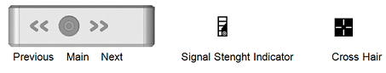

Mechanical Zeroing – Function Swithces, Signal Sterenght Indicator, Cross Hair (Figure 1.8)

When in the Mechanical Zeroing Mode the Signal Strength Indicator and Cross Hair are displayed. Mechanical zeroing is also assisted by a sound signal when the device is aimed at the center point of the target. When a dry-fire shot occurs during zeroing an adjustment hint is presented in the graphic display window using the following abbreviations: CW = (adjust) clockwise / CCW = counter clockwise. The approximate number of clicks needed is displayed as well.

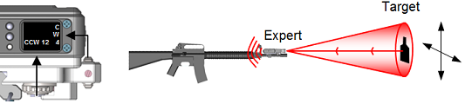

Mechanical Zeroing – Adjustment Display (Figure 1.9)

Vertical and horizontal adjustments are done by turning two screws with the provided 3 mm hex wrench (Allen key). **Note: Avoid too much force when reaching the limits of adjustments.**

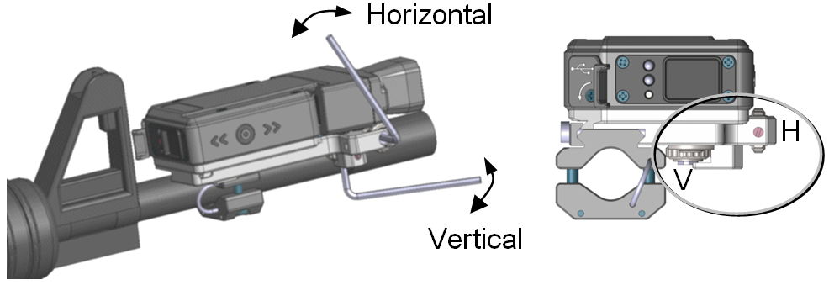

Mechanical zeroing – Adjustments (in default mounting position) (Figure 1.10)

When the FN EXPERT ***TM*** device is connected to PC computer, a software zeroing is available when operating in the Marksmanship mode.

### 1.1.4 Targets

The FN Expert ***TM*** Device uses both Silhouette and Ring Targets for training.

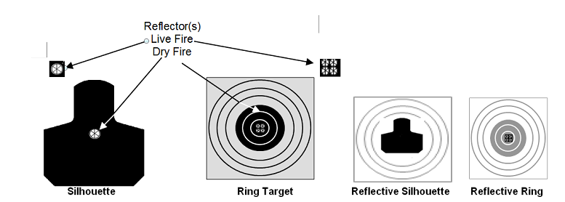(Figure 1.11)



Example silhouette and ring targets with and without P38 Prism Reflector

The plasticised reflective targets provided with set have a training range of 5 – 10 meters. Targets equipped with a optional single P38 prism have a training range of 5 - 75 meters. All of the above targets have a simulated range of 5 – 300 meters. The addition of more prisms increases the training range. Five prisms increase the maximum range to 150 meters. Training is practically independent of distance to the target. This way training for 300 meters range with M16 assault rifle, or any other distance/target combination, can be done with any available space. In addition, a target with reflective tape can be used at short ranges. For more information about conventional and pop-up targets, see “Targets and Precision”. Prisms are center mounted for dry fire, for live fire the prisms should be mounted on the edge of the target to avoid damage.

## 1.2 Using FN EXPERT *TM* device

### 1.2.1 Configurations

Typical training with the FN EXPERT ***TM*** device is divided in two operating modes: field or marksmanship**.** The FN EXPERT ***TM*** device operates as a stand-alone unit or connected to a PC. Therefore, there can be four different configurations as follows:

1. Stand-alone - Field Training

2. Stand-alone –Marksmanship Training

3. Connected - Field Training

4. Connected –Marksmanship Training

The two operational modes stem from distinctive needs in various training practices:

Field training allows military type, very quick and instinct reaction kind of shots with varying target distance both real and simulated.

Whereas marksmanship training is conducted in stable conditions the distance, real and simulated to the target remains the same from shot to shot.

Real distance is the actual measured distance to the target. Simulated distance is a scaled distance to the target this is enabled by the system to allow simulated distances in a small training area e.g. a simulated 300-meter target at an actual distance of 7 meters.

“Stand-alone” means independent operation without a computer. When the EXPERT system operates in the stand-alone mode, shots are stored in to the internal memory of the device. Stored aiming time per shot is around half a second in Field training and 1.5 seconds in Marksmanship training. All shots can be downloaded later to a PC via USB or Bluetooth connection.

The FN EXPERT ***TM*** has memory storeage available for stand-alone shots. 250 shots can be stored in Marksmanship training, or 1000 shots in Field training.



"Connected,” means cable connection to a computer via USB or wireless connection via Bluetooth (BT). In connected Field training the hit point will be shown immediately after a shot takes place. There is no real-time tracking or follow-up on the computer’s screen. In the Marksmanship training connected mode there is real-time tracking, follow-up on the computer’s screen and analysis available as well.

In connected modes the FN EXPERT ***TM*** device works under control of the computer. The main push button and arrow buttons should not be pressed during this training. When using the device with a computer, a ‘USB’ or ‘Y**BT**’ text with device’s (serial) number is shown in the graphic display for most of the time.

Warning: Do not use any other demanding software or USB devices during training measurements.

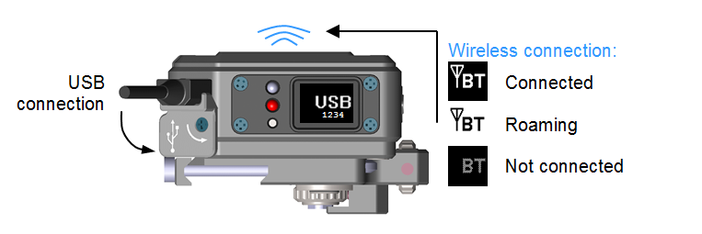

Connecting the FN EXPERT *TM* device to computer (Figure 1.12)

### 1.2.2 Function modes

The FN EXPERT ***TM*** device can be used as stand-alone device or it can be connected to a computer. When used as a stand-alone device, using three push buttons operates it: Main button and two arrow buttons. **(Currently no functionality is associated with the two arrow buttons.)**

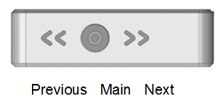(Figure 1.13)

User Interface – Push buttons

The FN EXPERT ***TM*** device is turned on by pressing the “Main” push button for one second and can be switched off by pressing the main button for two seconds. When the device is connected to a computer via USB cable or Bluetooth the buttons should be left untouched. The computer will then control the power supply automatically without any actions needed by the shooter.

The device is equipped with internal, high performance rechargeable lithium-ion battery, which has a wide temperature range and a high capacity. An automatic voltage check is performed whenever the device is turned on using the main switch or computer. The result is shown by a battery power icon display on the back of the device.

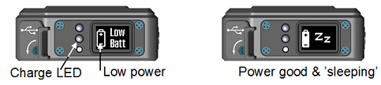 (Figure 1.14)

User Interface – Low power indication

If ‘Low power’ is shown, the voltage level is too low to be used in training and the internal battery must be recharged using the charger provided or by connecting the device to the computer’s USB port. When the battery is charging, a charge indication light (LED) turns on. In addition, the charge LED is used in mechanical zeroing to indicate center of reflective surface.

Typical operating time (per charge) exceeds 48 hours stand-alone this enables extended training periods with minimal recharging. Operating time when connected via Bluetooth exceeds 24 hours. If there are pauses between training sessions, the device should be turned off to preserve battery life.

There are two active functional modes: **Training** mode and **Setup** (zeroing) mode. Function modes are selected by pressing the main button for one second. Adjustments can be done with the aid of adjustment hints by shooting a shot during zeroing. To return to the setup/zeroing mode press the main button again. The main button is used to toggle between functional modes and accept setup options.

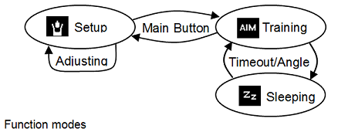(Figure 1.15)

In addition, there is a non-functional ‘Sleeping’ mode. The device goes to ‘sleep’ automatically, when the shooter is not pointing at the target **(Note: based on weapon angle)**. Waking up from ‘sleep’ back to training mode is automatic. The graphic display shows the shooter information during zeroing, training and setting options. The information displayed is easy to understand. Some examples:

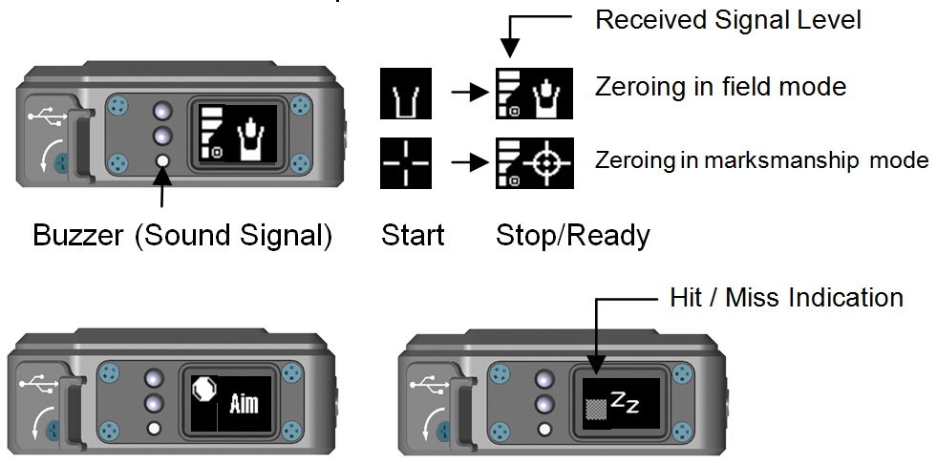

User interface & graphic display examples (Figure 1.16)

**2 Training examples**

**2.1 Field training**

The Field training session is usually performed stand-alone, without a computer. All shots during the action will be stored into internal memory of the FN EXPERT ***TM*** device. When required, the setups are done in advance with a computer. After the training action, all shots can be downloaded to a computer for reviewing. Field training may be preformed dry of live fire.

Special silhouette and ring targets for training can be implemented and uploaded to the FN EXPERT ***TM*** device using the FN EXPERT ***TM*** application software. The device stores targets until they are rewritten by the instructor.

The FN EXPERT ***TM*** Field training system consists of the following parts:

* FN EXPERT ***TM*** device.
* Target with a single prism reflector.
* Weapon.
* Optional: Computer, USB cable and EXPERT application program.
* Optional: Pop-Up target(s), Target Modules(s).

Training session is installed and started as follows:

1. Set the target(s) at the desired training distance.
2. Attach the FN EXPERT ***TM***  optical device to the weapon.
3. Connect to computer use application software to configure device for training.
4. Perform mechanical adjustment (zeroing)
5. Start training.

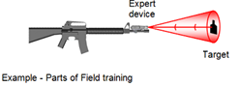(Figure 2.1)

**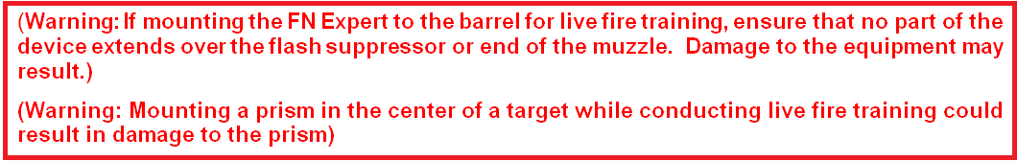**

**2.2 Marksmanship training**

Marksmanship Training can be performed with either a single EXPERT device or in a multi-user system (See Applications Chapter). EXPERT devices are normally connected to computers In the Marksmanship Training mode, shot analysis is done instantly and all shots are stored on the computer.

Training sessions may be performed indoors with special targets. With a suitable rugged computer and reflective or prism-equipped targets, the training can be preformed outdoors ,dry or live fire. A Marksmanship training session is performed using the FN EXPERT application.

The FN EXPERT ***TM*** Marksmanship Training system consists of the following parts:

* FN EXPERT ***TM*** (s) and USB cable(s), if desired.
* Target(s) with prism reflector(s) or reflective tape (classroom).
* Computer with Windows operating system and USB port(s) and or Bluetooth connection.
* EXPERT application.
* Weapon.

Training session is started as follows:

1. Set the target at the desired training distance.
2. Attach EXPERT optical device(s) to the weapon.
3. Connect the device(s) to the computer with the USB cable(s) or via Bluetooth.
4. Start the FN EXPERT ***TM*** application.
5. Select desired operating mode in EXPERT APPLICATION.
6. Perform mechanical adjustment or software zeroing, if needed.
7. Start training.

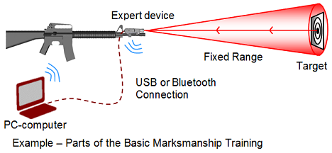(Figure 2.2)

****

# Application Software

When the FN EXPERT ***TM*** device is connected to a computer, the FN EXPERT ***TM*** application is used for setting options and training situations, and analysing training sessions.

Install the FN EXPERT ***TM*** application software by inserting the USB drive into the computer and selecting “**Open folder to view files using Windows Explorer”. Select “Noptellinstaller.exe”** option from the USB menu. Select **“Install Application”**

The FN EXPERT ***TM*** Application may also be installed by downloading the Application from the FN USA website: http://www.fnhusa.com/

 (Figure 3.1)

Under “**Products”** Select “**FN EXPERT”**under Shooting Training.

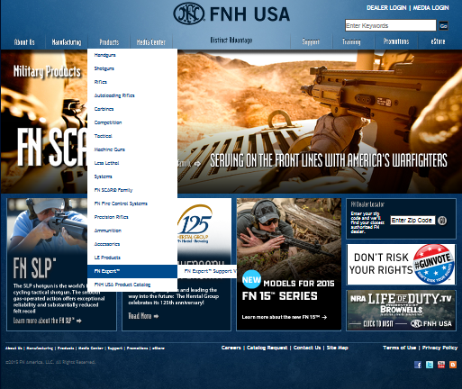

(Figure 3.2)

Under **“Download Software”** Select “Click here”

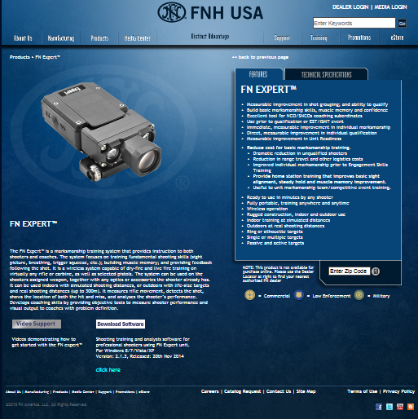 (Figure 3.3)

**Do you want to run FN\_Expert\_Install.exe** Select **Run**

**** (Figure 3.4)

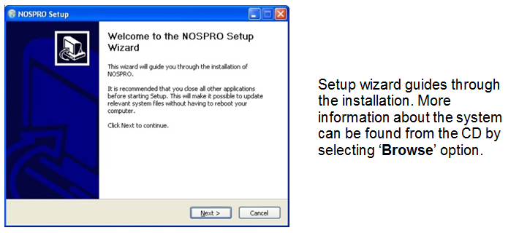

FN EXPERT ***TM*** application installation3.1 Start up (Figure 3.5)

**3.1 Start up**

FN EXPERT ***TM*** application is started by selecting: **Start ► Noptel Training Systems ► FN EXPERT. Windows 8►file Noptel 7\_1014** (Recommend placing FN EXPERT on Desktop staring application by clicking on EXPERT Icon.

When FN EXPERT ***TM*** application is started a following main selection window appears:

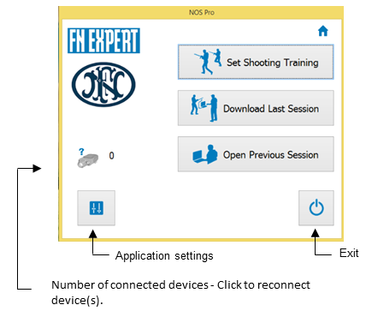 (Figure 3.6)

FN EXPERT - Main selection window

Connect

SVP_26_Bluetooth_Roaming Once the FN Expert ***TM*** Main Screen is displayed the application is waiting for Expert devices to be connected. Just connect the FN EXPERT device to USB port and wait for a while. When a new Expert device is connected to a Windows computer, the USB device driver is installed automatically. The number of connected devices can be seen on the bottom left corner of the main selection window.

Bluetooth_OK When Bluetooth is used, refer to computer's documentation to set up and enable wireless connections. Next, complete a pairing between the FN Expert and the computer the application software is installed on. **Please note, that the number of simultaneously connected Bluetooth devices is limited to 2.**

The next step is to set a shooting training session or download a previous training session's data from the FN EXPERT ***TM*** device, if available. Working offline using a previous session's data is also possible.

**3.2 User Interface**

The main control panel is used for controlling the tasks of all connected shooters.

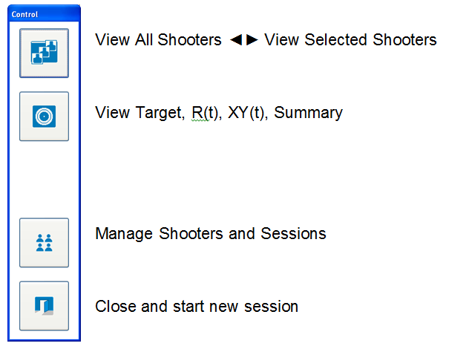

Main control (Figure 3.7)

Main function mode between training and software zeroing is selected using the zeroing button in the main button panel.

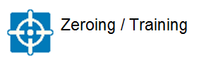

(Figure 3.8))

There can be several shooters connected at the same time. One or all shooters can be viewed on the screen.

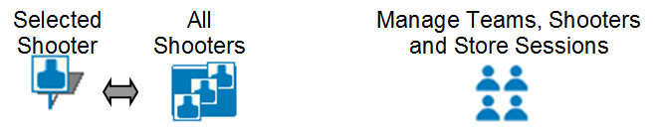

(Figure 3.9)

Basic and advanced marksmanship training sessions can be reviewed in several different view forms. Most common review is the target view, this view displays the trace data for a single shot. Additional views include R (t) and XY (t)**\***, which can be used in advanced mode only. The former displays distance to the middle of the target (resultant) and the latter horizontal and vertical movements on time scale. The all hits target view shows all shots taken during the current session and the average hit point for all shots. After actions summary view is available as well.

Replay view buttons:

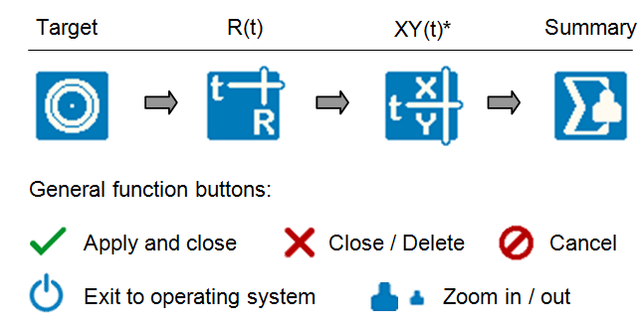 (Figure 3.10)

**3.3 Field training**



Field training is usually performed in stand-alone mode. Configuring the device for training and mechanical zeroing is done before training is conducted, if needed. During field training the shooter can see the previous hit/miss on the graphic display.

When the Expert operates as a stand-alone device, shooting training data is stored to the internal memory of the device. Stored aiming time per single shot is half a second. After training this data can be downloaded to computer for storing and reviewing.

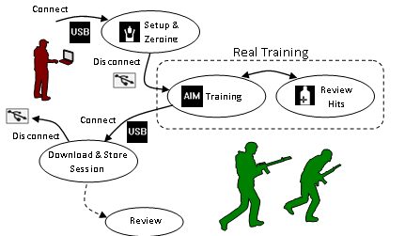(Figure 3.11)

Setup &

Zeroing

Training

onnect

isconnect

Example of (stand-alone) Field training session

A Field training session is started from the home screen by pressing ‘**Set Shooting Training**’ button. After that, the desired training setup (target) is selected from the ‘Setup List.’ Finally, the user can continue to one of the following tasks:

* **Setup** target and options for stand-alone training session
* **Start** selected training with connected Expert devices
* Set the mounting orientation of the device
* Edit training setup list and target (Tools button)

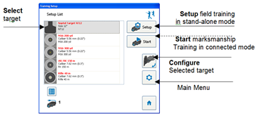

Training Setup window – Setup Field operating mode session (Figure 3.12)

To select desired mounting (see chapter 1.1.2) of the FN EXPERT ***TM*** device press ‘Set Device Mounting’ button several times.

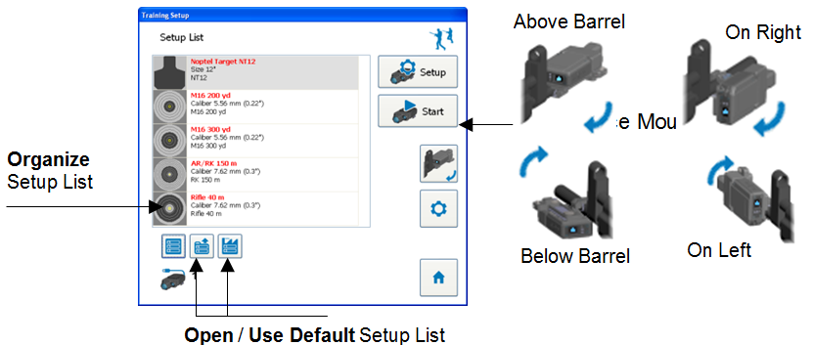

Training Setup window (Figure 3.13)

The setup list can be customized and stored on a mass media device such as memory stick etc. Previously created setup lists can be copied to other computers and opened quickly when needed. Read chapter 3.5.4 to enable advanced settings and then press ‘Organize Setup List’ button to see more buttons as follows:

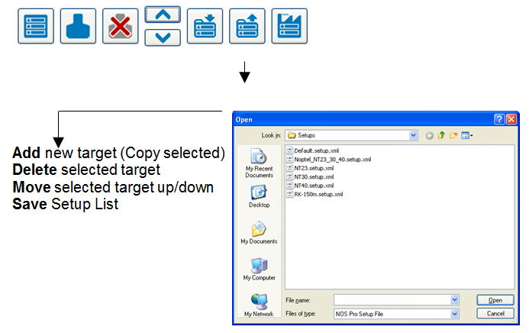

Organize customized setup list (Figure 3.14)

**Note: Default setup file can also be selected to be permanent in application settings by pressing ‘Defaults’ button.**

### Configure2 3.3.1 Setup silhouette options

Field training is usually performed outdoors, in the field or in an urban environment. The most common target used is a silhouette figure. To set up a new training situation, the FN EXPERT ***TM*** device is connected to the Computer.

In the ‘Training Setup’ dialog window select desired target and press ‘**Configure…’** button to open a ‘**Training Options**’ window. In ‘Training Option’ window there are two control tabs available: General and Silhouette.

**General options Remarks**

Description text to be shown in the setup list

Silhouette Target Number selected silhouette target (1..10)

Hit Indication Beam sends optical beam to target when hit

Number of Prisms normally 1 (computers) for 5 .. 75 m ranges

and more for longer distances

Cocking Delay typical time to reload new cartridge (s)

Shot Rejection Angle angle limit for ignoring all shots (º)

Limit rounds to X shots countdown to zero ► disable shooting

Trigger Sensitivity Light ◄ Normal ► Heavy

(slide bar) Set heavier to avoid false triggers!

In addition, there are some advanced controls for instructors. Read chapter 3.5.5 about advanced silhouette settings.

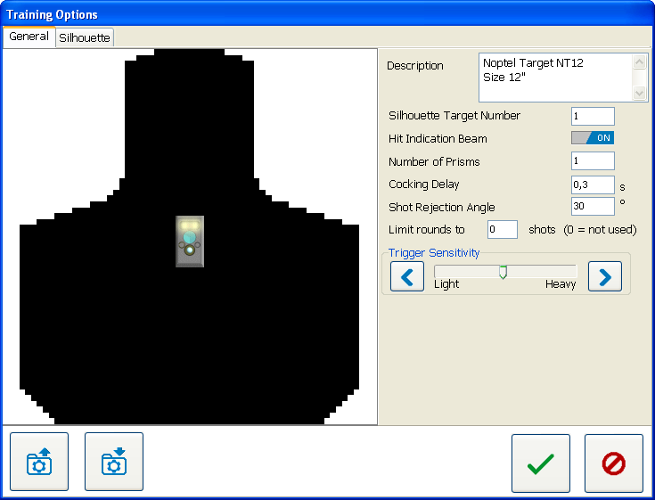

General Training Options (control tab) page(Figure 3.15)

### MainMenu_Download 3.3.2 Download session

Connect The latest training session is uploaded from the FN EXPERT ***TM*** device’s internal memory to the Computer using a download pop-up dialog window. The dialog is opened from the main selection dialog.

The download process start-up is automatic – connect the FN EXPERT ***TM*** device to the USB port using the USB cable provided or using a Bluetooth connection and wait for a while. Do not disconnect the USB cable before download is complete.

While downloading shooting training data from the FN EXPERT ***TM*** device, the name of the trainee can be entered in the ‘**Shooter name**’ edit line. However, the shooter name can be entered later.

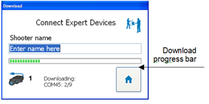

Download pop-up (Figure 3.16)

Elapsed time and remaining download time can be estimated from the progress bar.

### MainMenu_OpenPrevious 3.3.3 Review session

Review of shots is displayed two different ways: **All shots** or **Single shot** view. When a single shot is selected a location of miss and hit (LOMAH) can clearly be seen in the center of the large grey ‘crosshair’.

On the all shots view one shot can be highlighted with a white crosshair by clicking the icon on the timeline at the bottom of the view. If shooting has been very quick (controlled pairs) the shots are grouped together automatically in the single shot view.

To view an individual shot with the aiming trace double click the shot on the timeline. All shots can be seen again by clicking anywhere on the target..

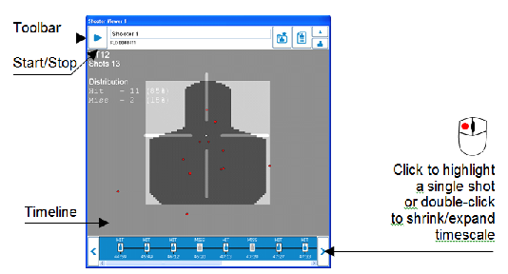

Example field training session – All shots view(Figure 3.17)

The Toolbar includes command buttons and the shooter’s information. ‘**Start/Stop’** (► ▌▌) button is used to start and stop real time measurement. Tilt (ok/limits) and rotation angle (cant) during aiming are displayed with icons next to the '**Star/Stop**' button. ‘**Save**’ (to folder) button is used for storing the session to mass media.

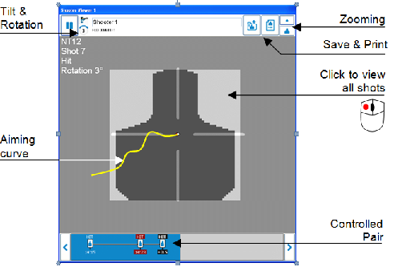

Example field training – Single shot view(Figure 3.18)

**3.4 Marksmanship training**

Training in a class room or on a shooting range is usually performed in the connected mode. Prior to training configure the device and mechanical or software zero if needed. During Marksmanship training the shooter can review and analyse shots on the Computer display.

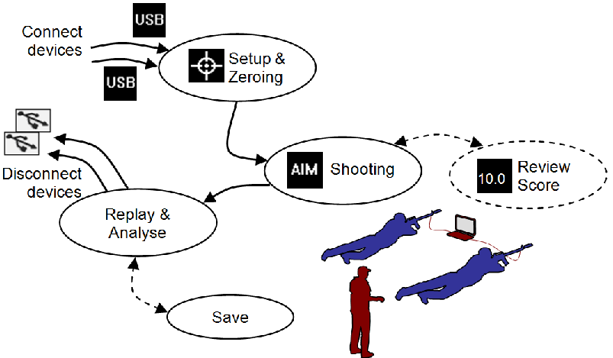

Example of Marksmanship training session(Figure 3.19)

A Connected Marksmanship training session is started from “Training setup” window by first selecting the desired target setup and then pressing ‘**Start**’ button.

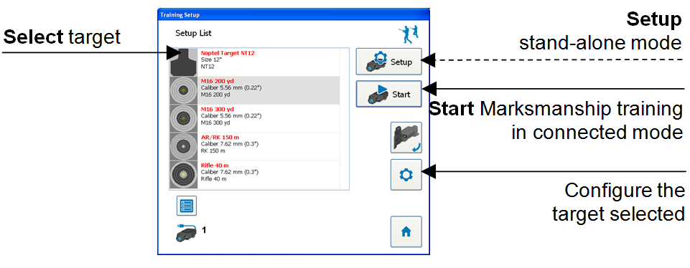

Training Setup window – Start Marksmanship training session(Figure 3.20)

A Stand-alone training session is started from the from the “Training setup” window by first selecting the desired target setup and then pressing the ‘Setup’ button. In this case the score of the hit point can be seen on the graphic display of the device.

When the FN Expert operates as a stand-alone device, shooting training data is stored to the internal memory of the device. Stored aiming time per single shot is 1.5 seconds.

### Configure2 3.4.1 Setup and edit ring target

Marksmanship training is usually conducted in a classroom environment, where the most common target is the ring target. General options of ring target are edited using ‘Training setup – **Configure… ►**’Training Options’ **►** ‘**General**’ control tab. A preview of the target is visible on the left side of the control tab while options are set.

**General options Remarks**

Description text to be shown in the setup list

Trigger Sensitivity Light ◄ Normal ► Heavy

(slide bar) Set heavier to avoid false triggers!

Cocking Delay rest time between the shots (s)

Shot Rejection Angle angle limit for ignoring all shots (º)

Limit rounds to X shots countdown to zero ► disable shooting

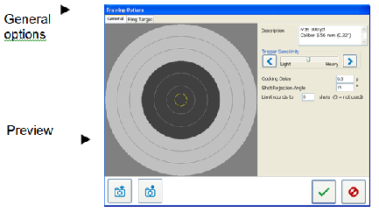

General Ring target options page(Figure 3.21)

Ring target dimension can be edited in the ‘**Ring Target**’ control tab:

**Ring target options Remarks**

Name in Experts’s Display name to be shown in graphic display

Simulated Distance for e.g. 10-300 m (100, 200, 300 yd)

Caliber 5.56 mm (0.22”), 7.62 mm (0.30”), etc.

Highest Ring normally 10, but can lower (.10)

Lowest Ring normally 1, but can be higher (1..)

Use Inches meters or yards / mm or inch

X-ring Diameter diameter of the ‘bulls eye’ (mm)

Highest Ring Diameter diameter of the ‘ten-ring’ (mm)

Hit Ring Gap the gap between the rings (mm)

Inner White Diameter set if there is white area center (mm)

Black Area Diameter (the ring) from which black starts (mm)

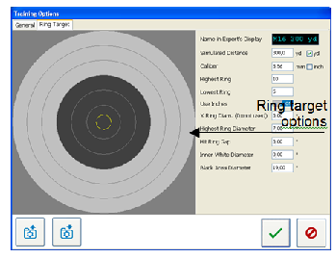

Ring target options page(Figure 3.22)

When the target is ready it is updated to the training setup list by pressing **Ok**. Target can be saved to a mass storage media or stored to the internal memory of the FN EXPERT ***TM*** device using ‘**Misc.’** control tab. Then target can be selected to be used in the training session from the menu of the FN EXPERT ***TM*** device. In addition, targets can be opened from the disk or loaded from memory of the device for editing.

### 3.4.2 Software zeroing

ZeroingZeroingSoftware zeroing is available in connected Marksmanship mode. Software zeroing is started by pressing the button in toolbar of the single shooter window or on the main control panel for all shooters. Pressing the button again switches back to shooting.

A zeroing point is calculated automatically based on last three shots. The zeroing point must be inside the yellow zeroing limits circle. If current aiming point crosshair is outside the circle, use mechanical adjustments to correct aiming point inside the circle (chapter 1.1.3).

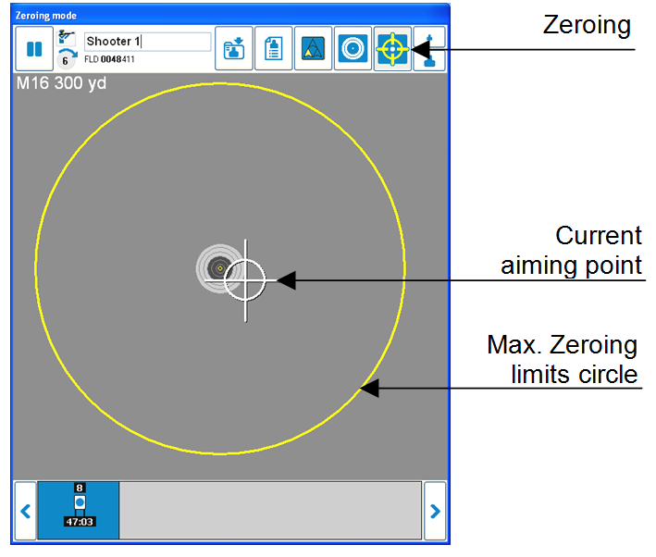

Software zeroing(Figure 3.23)

### 3.4.3 Analysis model

In the marksmanship training analyis model shooting performance is divided in three result factors: **hold**, **aim** and **trigger control**, the basic elements needed for successful results.

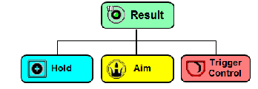

Marksmanship training analysis model – Result factors(Figure 3.24)

After each shot a quick grading of shooting analysis is displayed on each shooters display. Quick grading can be shown only when there is enough aiming sample available to be used for statistical calculations. Normally at least 1.2 seconds of aiming trace data is needed.

### ReplayXY 3.4.4 Reviewing and quick grading

Review of the shots can be seen in several ways. The most common review form is the **target view**. In the target view the last shot is displayed as a white dot in the middle of a hit crosshair. All previous shots are drawn in red. The result score with hit sector of the last shot is displayed at the upper left corner of the target view.

A toolbar at the top of the window includes functions that can be done for selected shooter window only, such as start software zeroing, review a single shot or change quick grading skill level. The timeline can be used to find good or missed shots quickly and to select single shots for review. Double clicking on the timeline changes the timescale.

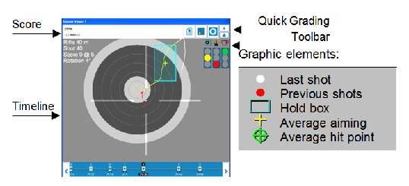

Example of a target view elements(Figure 3.25)

A hold box of the last shot is drawn in blue. A smaller hold box represents better hold skill. The hold box spreads wider or higher in proportion to horizontal and vertical movement. If hit point is inside the hold box, it represents good trigger control - a hit point outside the hold box might be the result of poor trigger control.

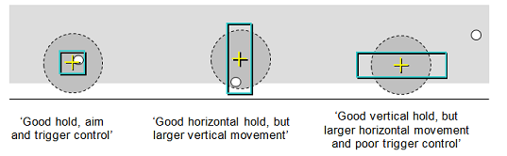

Examples of evaluating holding ability and trigger control(Figure 3.26)

A quick grading of the training performance is displayed using indicator lights (‘traffic lights’) in the upper right corner of the shooters view. An upper green light indicates good performance in the factor evaluated. A lower red light means weaker and yellow average performance. Quick grading can be enabled or disabled in Application Settings window (chapter 3.5.4).

Quick grading is based on the skill level and shooting position selected. Skill level can be changed by clicking the icon in the toolbar. Shooting position setup is available in advanced use only.

Quick grading elements (\*default)

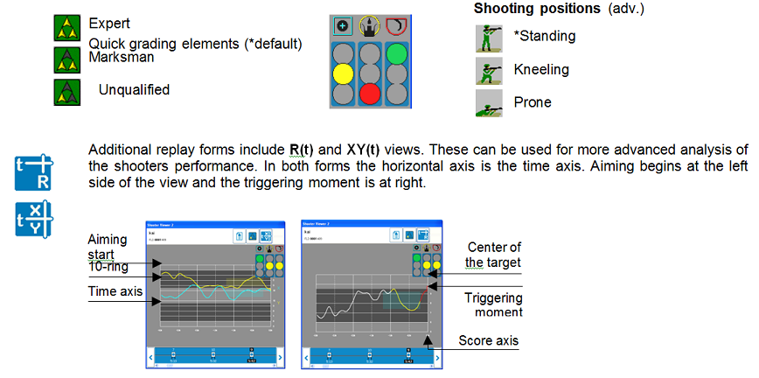

Examples of XY(t) and R(t) reviews(Figure 3.27)

R (t) window displays the distance to the middle of the target (resultant vector). XY (t) view shows the aiming process divided into up/down (Y) and left/right (X) movements. XY (t) view can be seen in advanced use only.

A target view with **all hits** including a center-of-gravity hit point is available. There are no statistical elements (hold box and average aiming markers of the last shot) on all hits view. A distribution of all shots can be seen on the left side of the view.

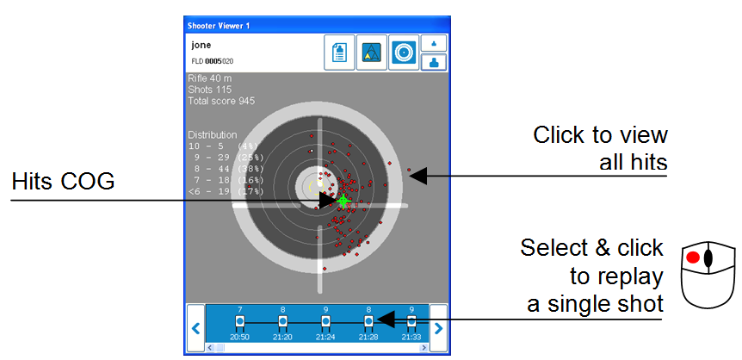

Example of a all hits target view(Figure 3.28)

### 3.5 Additional features

### 3.5.1 Session summary

SummaryRangeTraining session **summary** can be viewed whenever the button is available in the toolbar. In simulated training mode summary includes shot number, score (@ sector), aiming time in seconds (AimT), center-of-gravity points (aim COGX/COGY) and deviations (hold DevX/DevY) in rings, and quick grading results. In real training mode the summary consists of hit/miss and timing information only.

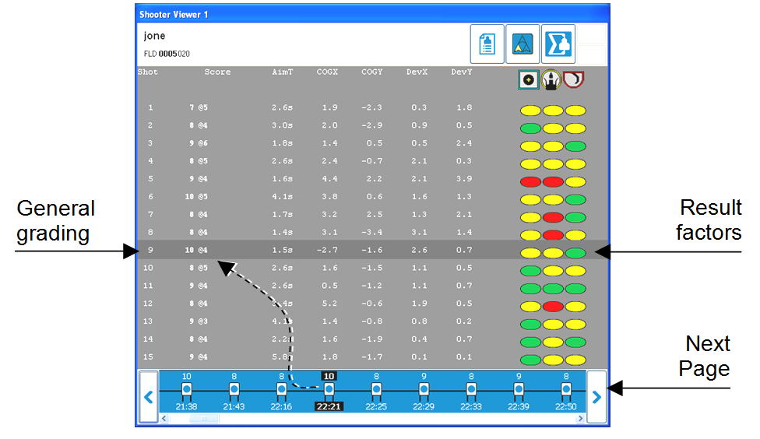

Example of training session summary window(Figure3.29)

**3.5.2 Manage teams, shooters and sessions**

ShootersShooter can be organized into teams. For that press upper right button to open **Name List Editor**, where teams and shooters can be created and removed, and also saved to or loaded from NOS Pro Name List (XML) file.

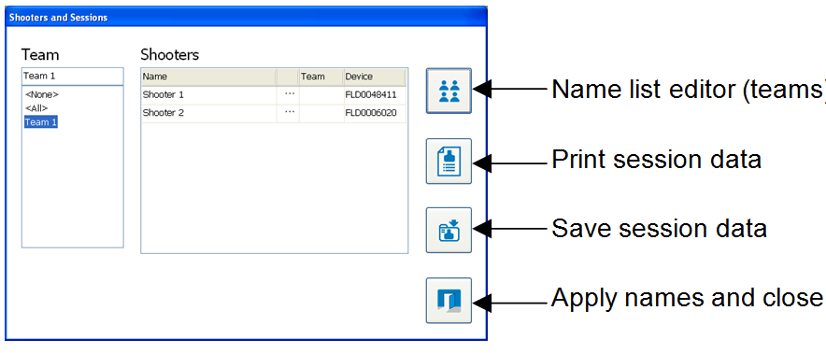

Shooters and Sessions & Name List Editor(Figure 3.30)

Press ‘Save session data’ button to save session data to disk. Press ‘Print session data’ button to print session results of all shooters. Please note, that separate printouts for individual shooters can be done from shooter viewer’s toolbar, too.

When teams are present, first select team and then press ‘**…**’ marks (fig. 41) for searching and selecting the shooter from the list of names of the team selected (fig. 43).

Press ‘Name list editor’ button to add and manage shooter names and teams.

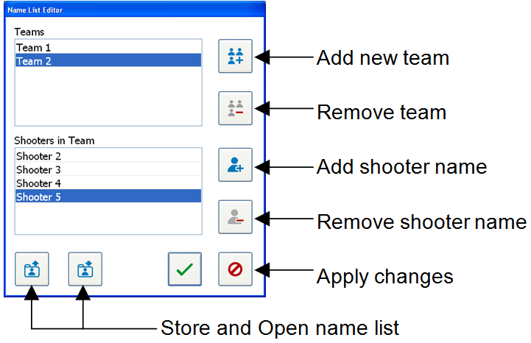

Name List Editor(Figure 3.31)

In the case of large teams the list of the teams shooter names can easily. To find a shooter from the list type some letters into the **‘Search’** field. Shooters whose name matches the letters are displayed in the list of the teams shooters below. Select the shooter name and press apply button to copy the name selected to the shooters and sessions window.

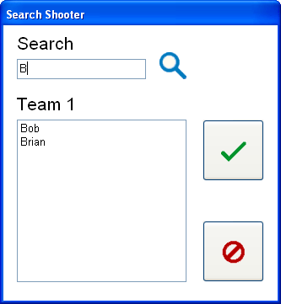

Search shooter window(Figure 3.32)

### 3.5.3 Open previous session

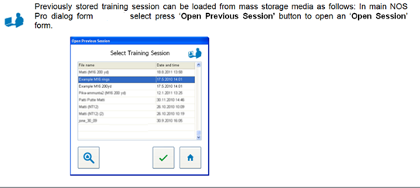

Open session window(Figure 3.33)

First select desired training session from the list of available sessions and then press ‘√**’** button. If desired session is not on the list then press search button to browse other folders.

### 3.5.4 Application settings

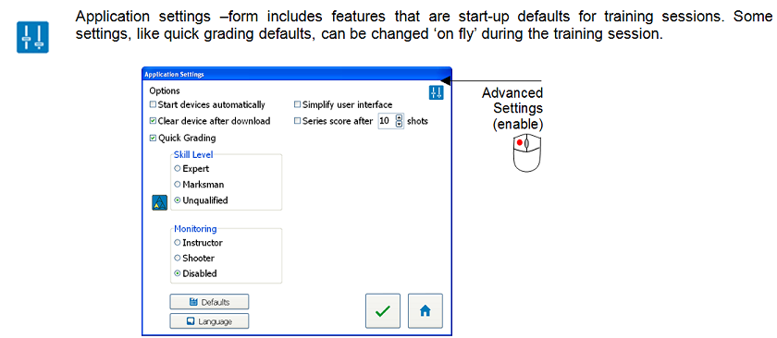

Application settings window(Figure 3.34)

Application user interface language can be changed by pressing ‘**Language**’ –button. Desired language is selected from the list of available language files. Each language file can be edited using any available text file editor, such as standard Windows Notepad. After selecting language, press ‘**OK**’ and restart the application.

For instructor and network use there is some advanced settings available. Advanced settings can (temporarily) be used by double clicking the following icon in the Application Settings window:

 (Figure 3.35)

**Options Remarks**

**\_\_\_\_\_\_\_\_\_\_\_\_\_\_\_\_\_\_\_\_\_\_\_\_\_\_\_\_\_\_\_\_\_\_\_\_\_\_\_\_\_\_\_\_\_\_\_\_**

Start devices automatically start measuring on startup

Clear shots after download clear internal memory of the device

Quick Grading show/hide quick grading & summary

Simplify user interface show/hide some toolbar buttons

Series score after X shots clear target view after shots given

**\***Send training data to network - see more on chapter 4.3.3

**Quick Grading Defaults Remarks**

­­­­­­­­­­­­­­­­­­­­­\_\_\_\_\_\_\_\_\_\_\_\_\_\_\_\_\_\_\_\_\_\_\_\_\_\_\_\_\_\_\_\_\_\_\_\_\_\_\_\_\_\_\_\_\_\_\_\_\_

Skill Level Expert, Marksman or Unqualified

**\*** (Shooting) Position Standing, Kneeling or Prone

**\_\_\_\_\_\_\_\_\_\_\_\_\_\_\_\_\_\_\_\_\_\_\_\_\_\_\_\_\_\_\_\_\_\_\_\_\_\_\_\_\_\_\_\_\_\_\_\_\_**

**Network Monitoring Remarks**

Monitor, Node, Disabled see more on chapter 4.3

### 3.5.5 Advanced settings for instructors

Options of the silhouette target can be edited using ‘Configure Selected Item **►**Training Options **►** **Silhouette**’ control tab. A preview of the silhouette can be seen on the left side of the control tab while options are set. Use **Ok** button to update training setup list when options are ready. Advanced Options group includes the following settings:

**Advanced option Remarks**

**\_\_\_\_\_\_\_\_\_\_\_\_\_\_\_\_\_\_\_\_\_\_\_\_\_\_\_\_\_\_\_\_\_\_\_\_\_\_\_\_\_\_\_\_\_\_\_\_**

Experts’s Display view hit/miss on device display

Play Sound On Hit Internal buzzer on/off

Automatic Sleep/Wakeup use sleep mode or be ready alltime

Sleep Timeout delay time before going to sleep (s)

Sleep Angle angle limit for sleep mode (º)

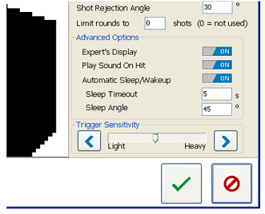

General Advanced Options for silhouettes(Figure 3.36)

The buttons on the bottom of training options window are common for all targets. They can be used to load and save target setup into FN EXPERT setup files (XML-files). If needed, check general silhouette options on chapter 3.3.1.

options will show up when advanced settings are enabled only.

**Silhouette options Remarks**

Target Name name of target (for graphic display)

Use Imperial Units select metric units or inches/yards

Nominal Distance typical shooting distance (5-75 m)

Silhouette Size physical size of the silhouette target, **Note: Use width or hight of the target, whatever is larger.**

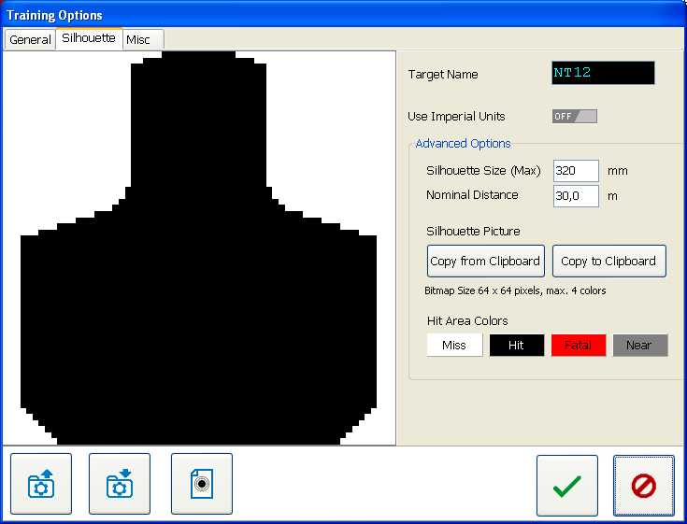

Silhouette options page(Figure 3.37)

Any paint application can be used to draw and resize the target silhouette bitmap to correct resolution.  **‘Copy to Clipboard**’ and ‘**Copy from Clipboard**’ buttons are used through standard Windows Clipboard (copy/paste). Bitmap resolution for all silhouettes is fixed to 64 x 64 pixels. For one silhouette pixel 4 colours can be used as follows:

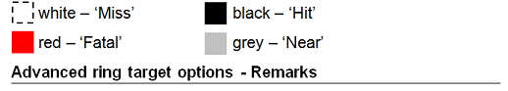(Figure 3.38)

Decimal Scores displays decimals on application software and in Expert’s display

Custom Rings open setup tab for customized rings

Hit Indication Score Limit last ring for sending hit incation beam

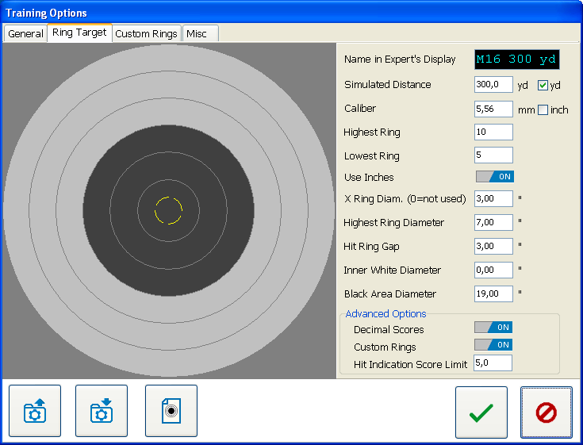

Advanced options for ring targets(Figure 3.39)

‘**Misc.**’ training options control tab includes user specific features for customizing Expert device’s features. For e.g. a ring target may be used together with a silhouette target to add detailed result scoring instead of plain hit/miss information. Miscellaneous controls are common for both Field and Marksmanship training and may vary in different versions of the application software. To begin set ‘Enable Settings on Device’ to ON position.

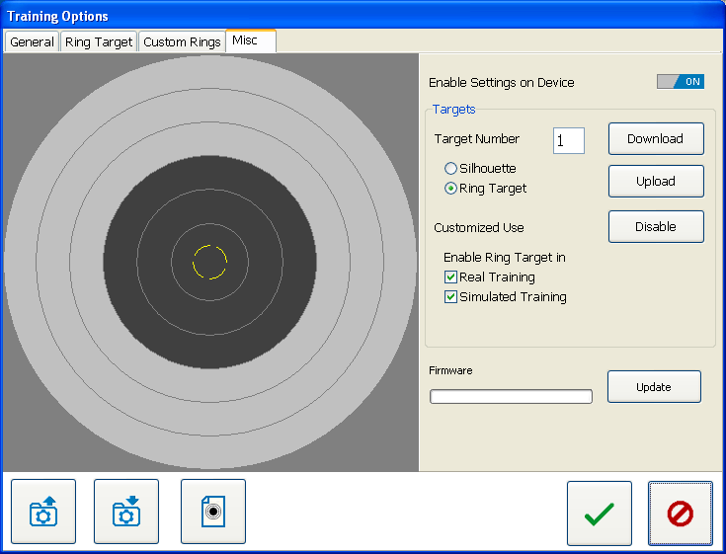

Miscellaneous options page for Expert device(Figure 3.40)

**Targets Remarks**

**Download** read target from Expert’s internal memory

**Upload** write target to Expert’s internal memory

**Disable** disable target (temporarily)

**Update**  maintain firmware icons etc.

**Customized Use** Enable selected target in:

Real Training and/or Simulated Training

### 3.5.6 USB device drivers

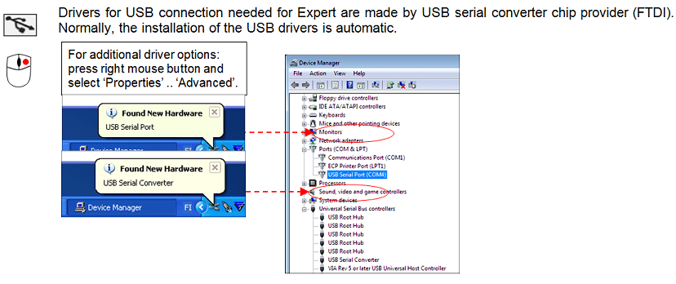

Windows Control Panel/Device Manager - USB device drivers(Figure 3.41)

However, if USB drivers are not available in the operating system, an Internet connection and ‘**Check for updates**’ in ‘Control Panel ► System (and Security) ► Windows Update’ is needed. Checking and installing must be done twice; first run for installing ‘USB Serial Converter’ and second time for ‘USB Serial Port’.

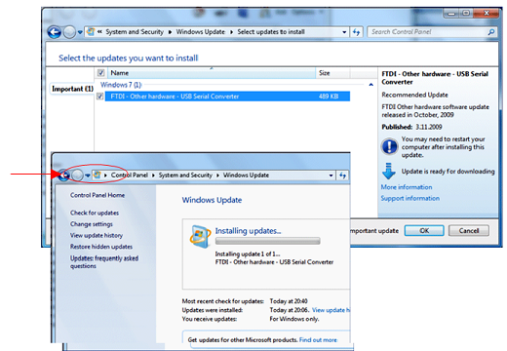

Example – Windows 7 Update, FTDI USB device drivers (Figure 3.42)

Additional sites for download and update USB drivers:

# Additional information

The Optical Measurement Part is a LED (Light Emitting Diode) device with an optical emission that is safe to the human eye (see chapter 4.6 "Warnings and classifications")

**4.1 Targets and precision**

Silhouette figures can be used with a target equipped with a P38 single prism, which is placed to the desired center point of the target for dry fire.



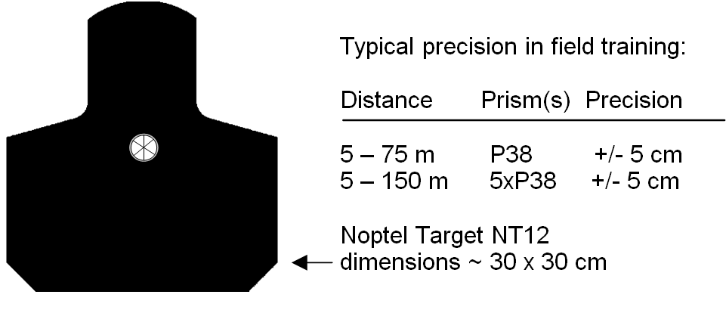

Example of silhouette(Figure 4.1)

In many cases the FN Expert ***TM*** is able to operate below specified minimum distance. Sometimes “HIT CRH” (Close Range Hit) might be displayed, which indicates that exact hit point calculation is not possible.

Note: At longer ranges in advanced training more prisms are needed in order to retain precision.

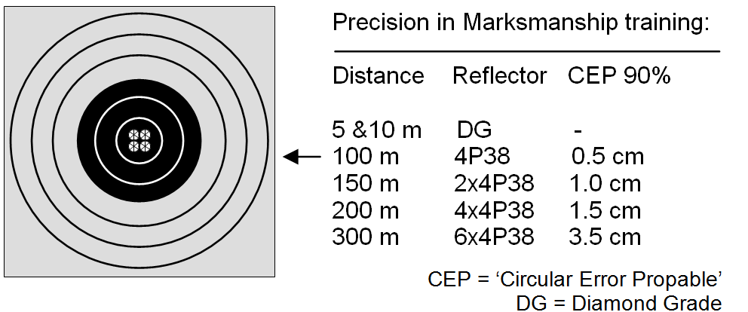

Example of a typical ring target dry fire placement. (Figure 4.2)



Mechanical zeroing is assisted by wide Field-Of-View (FOV, 30 mrad\*) sound signal around center point.

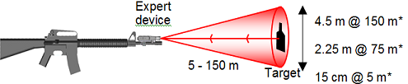

Mechanical zeroing area (Figure 4.3)

Software zeroing ‘area’ limit is 25 mrad\* and zeroing is based on calculating Center-Of-Gravity (COG) point of last tree shots in zeroing mode.

\* mrad = milliradian. 1 mrad = 0.1 m diameter (area) at 100 meters.

In addition, an optional Target Module can be added to the target in order to hide the target when it is hit (Pop-Up & turning targets). This can be done using a Hit Indication Beam (HIB) sent by Expert device.

The operating principle is that if the hit point is detected to be on a specified silhouette, the HIB is activated.

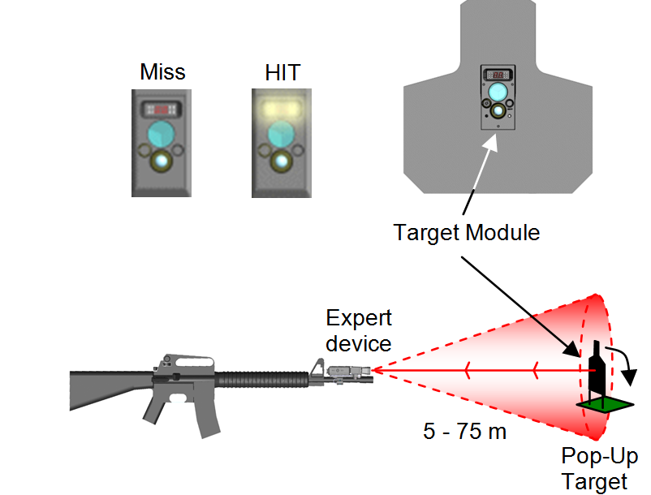

Pop-Up Target with Hit Indication(Figure 4.4)

HIB operating range is up to 75 m with NTM-10 Target Module and longer with optional prisms (NTM-10 ER).

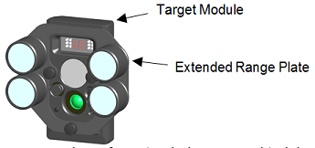

Adding more prisms for extended range training(Figure 4.5)

In some cases aiming or triggering is not detected correctly. Rejection of aiming or of a single shot can happen for various reasons. For e.g. too low/high received signal level or weapon angle usually means that the shooter is not pointing at proper target, the target is too close or far away, or might not have enough prisms attached on it.

The following icons are displayed in the shooters view toolbar when those conditions exist:

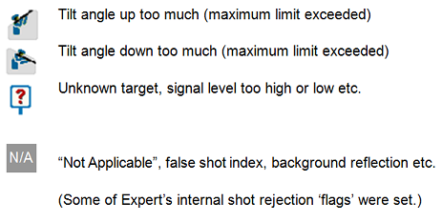(Figure 4.6)

**4.2 Multiple shooters**

Several Expert devices can be connected and used simultane­ously. Several shooters can shoot at the same target simultaneously. Alternatively, all shooters can shoot at their own targets as well.

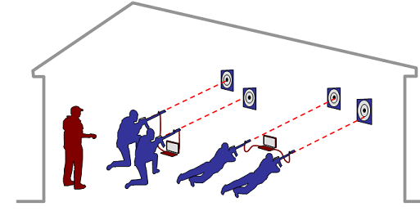

Example of classroom / indoor Marksmanship training (Figure 4.7)

An easy solution for training several shooters at the same time is to have one computer shared between two shooters. More flexibility can be obtained with Bluetooth connections.

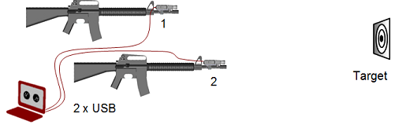

Multi-user system (Figure 4.8)

The number of USB ports per computer can typically be increased using USB HUB, which may have for example 4 USB ports. Please note, that measuring multiple aiming tracks in real time may slow computer performance and it might be necessary to reduce latency setup of the USB device driver under ‘Advanced’ options in Windows Control Panel.

When wireless Bluetooth connections are used two optical devices may be connected. The transmission bandwidth may be reduced due to ‘air traffic’ of other Bluetooth or Wi-Fi devices, for e.g. mobile phone Bluetooth accessories, PC/WLAN connections etc.

**4.3 Monitor training**

MainMenu_MonitoringMainMenu_MonitoringA network can be used for monitoring training sessions. In this case, all shots from several computers are sent to a monitor computer, which can be used for review, storing and printing. For monitoring, all computers are connected to the network. The instructor’s computer acts as the monitor and all other computers are nodes for individual shooters.

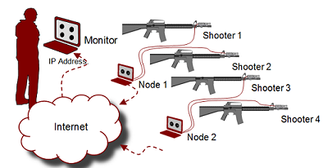

Example setup of network monitoring (Figure 4.9)

Advanced_SettingsSetting up for monitoring is done in application settings (chapter 3.5.4). Internet **IP-address** (and IP-port) of the Monitor computer is all that is needed. Press ‘Instructor’ radio button on monitor computer’s settings and write down its IP-address and port number. After that, press ‘Shooter’ radio button on all node-computers and enter instructors’ IP-address and port on the fields on right. Final**l**y, press ‘Ok’ to store and return to main menu.

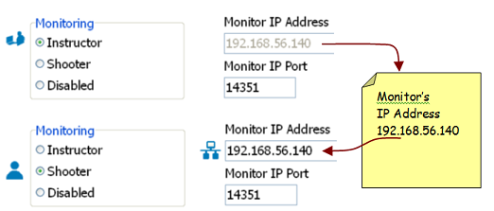(Figure 4.10)

Setting IP-addresses for monitoring on Application Settings

When IP-address of the monitor computer is entered into all nodes, press ‘**Monitor Training Session**’ -button on main menu of the monitoring computer. After that the monitor computer is searching for connections and nodes can be started. Now, copies of all shots from nodes can be seen on the monitor computer.

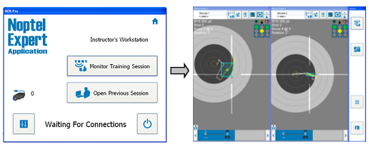

Monitor training session (Figure 4.11)

Each Expert-device has a unique serial number, which is used to identify devices from each other. If a new session is started using the same Expert-device, previous session data in corresponding shooter view is erased automatically. Thus, it’s a good practice to save session data after the training session is done.

**4.3.1 Text messages**

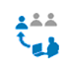 Monitor computer can be used to send a short text message and instructions to all shooters or to an individual shooter by pressing a message button. The text message is displayed on shooters view and in the FN EXPERT ***TM*** device’s display.

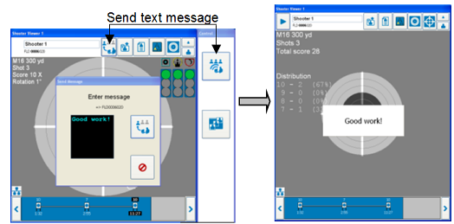

Sending text message from instructor to shooter (node) (Figure 4.12)

Text messages can be used for e.g. to give instructions, guidance, commands or recommendations of how to improve shooting skills. To ensure that the text message is noticed by the shooter, the actual measuring is stopped automatically. The length of the text message is limited to maximum of 60 characters (ASCII table page 1).

**4.3.2 About network connections**

FN EXPERT ***TM*** application must be allowed access permission to use the network on which the monitor computer(s) reside to avoid issues with operating system firewalls or virus & security software.

**Note: Sometimes network connection may be lost. For example, computers can hibernate or shut down to save battery power when they are not in active use. In this case, it is a good idea to increase the length of the computers power saving timeouts.**

Network connection status icon can be seen on shooter view’s bottom left corner as follows:

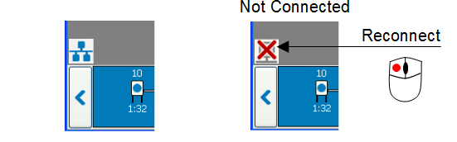

Network connection status icon (Figure 4.13)

If network connection is lost, the training session can continue normally. Later, by clicking on shooters view network connection status icon, shooters can try to recover the network connection.

**4.3.2 About network connections**

The monitor computer can use specialised user application software instead of the FN EXPERT ***TM*** application. In this case node computers send shooting data out to the monitor computer as simple (XML) frames. To enable this feature select the option ‘Send data to network’ in Application settings (advanced feature). The IP-address and port are the same that are used in normal monitoring.

Please notice, that user’s application software is not programmed or provided by Noptel, and data out feature is available on marksmanship training mode only.

**4.4 Service, updates and disposal**

The FN Expert ***TM*** device is rugged, but unnecessary mechanical impacts should still be avoided. Unclean transmitter or receiver lenses will reduce the operating distance. The lenses should be cleaned with moistened cloth as necessary.

**The Expert device should be wiped dry after each exercise.**

**Prism reflectors should be kept clean.**

The Expert device may be opened and serviced only by personnel or service points authorised by the manufacturer.

Updates of the application software can be found at the FN USA website: http://www.fnhusa.com/

Noptel’s Firmware Updater is used to load an updated controller code to the optical unit. The controller code’s HEX file is provided by Noptel personnel. First select “Expert” device, then open USB port, and finally open and load HEX-file from PC to Expert device. The number of the COM-port can be changed by pressing the “Tools” –button, if needed.

### 

Firmware updater (Figure 4.14)

****

# Live fire training

**5.1 Conducting live fire training with the FN Expert**

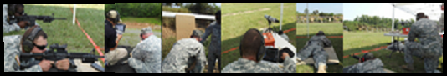 (Figure 5.1)

The FN Expert should be mounted prior to the zeroing of the weapon's optics/sights and retightened prior to zeroing the device. (See Chapter 1.1.1 for mounting)

Mount the reflective surface on the desired target. The reflective surface/prism does not need to be mounted in center of the target area. It can be offset in order to reduce the risk of damaging equipment down range. This is especially true if training being conducted is beyond 25 meters and reflective prisms are required to ensure sufficient light is returned to the receivers.

Zero the weapon's optics/sights prior to zeroing the FN Expert.

Run the FN Expert software and set the device up for training. (See Chapter 3 for device set up)

Mechanically zero the device to the reflective surface/prism while the weapon optics/sights are aimed at center mass of the target. (See Chapter 1.1.3 for mechanical zero)

Complete a software zero if necessary. (See Chapter 3.4.2 for software zero)

Conduct training. (See Chapters 2 and 3 for conduct of training)

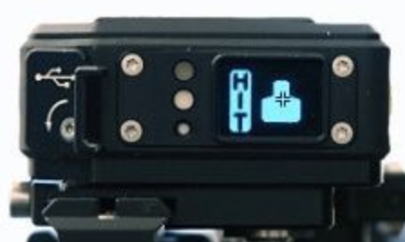 (Figure 5.2)

Its important to note that the muzzle location at the completion of the shot displayed on the screen will not necessarily match the shot hole in the target downrange. The system does not have the capability to represent factors such as MOA error in ammunition and weapon, effects of air density, wind, or other external factors that affect the ballistic performance of a projectile.

****

# Getting Help

FN Contact information for:

Equipment Support/maintenance

Software Support/Software Upgrades

Ordering Equipment

Ordering Training

**FN EXPERT *TM* ILLUSTRATION FIGURE LIST**

**Chapter 1 GENERAL**

Figure 1.1 ­­­­­­­­­­­­­­­­­­\_\_\_\_\_\_\_\_\_\_ FN EXPERT ***TM*** Training System

Figure 1.2 ­­­­­­\_\_\_\_\_\_\_\_\_\_ Optical Measurement Part (OMP)

Figure 1.3­­­­\_\_\_\_\_\_\_\_\_\_\_Mounting OMP

Figure 1.4\_\_\_\_\_\_\_\_\_\_\_Mounting OMP Barrel Clamp

Figure 1.5\_\_\_\_\_\_\_\_\_\_\_Adapting Picatinny Clamp

Figure 1.6\_\_\_\_\_\_\_\_\_\_\_\_Mounting to Barrel M16

Figure 1.7\_\_\_\_\_\_\_\_\_\_\_\_Examples Alternative mounting to a Picatinny Rail

Figure 1.8\_\_\_\_\_\_\_\_\_\_\_\_Mechanical Zeroing – Function Swithces

Figure 1.9\_\_\_\_\_\_\_\_\_\_\_\_ Mechanical Zeroing – Adjustment Display

Figure 1.10\_\_\_\_\_\_\_\_\_\_\_ Mechanical zeroing – Adjustments

Figure 1.11­­\_\_\_\_\_\_\_\_\_\_\_ Example silhouette and ring targets with and without P38 Prism Reflector

Figure 1.1­2\_\_\_\_\_\_\_\_\_\_\_ Connecting the FN EXPERT *TM* device to computer

Figure 1.1­3\_\_\_\_\_\_\_\_\_\_\_ User Interface – Push buttons

Figure 1.1­4\_\_\_\_\_\_\_\_\_\_\_ User Interface – Low power indication

Figure 1.1­5\_\_\_\_\_\_\_\_\_\_\_Function Modes

Figure 1.1­6\_\_\_\_\_\_\_\_\_\_\_ User interface & graphic display examples

**Chapter 2 TRAINING EXAMPLES**

Figure 2.1\_\_\_\_\_\_\_\_\_\_\_­­\_Parts of Field Training

Figure 2.2\_\_\_\_\_\_\_\_\_\_\_­­\_ Parts of the Basic Marksmanship Training

**Chapter 3 APPLICATION SOFTWARE**

Figure 3.1\_\_\_\_\_\_\_\_\_\_\_­­\_http://www.fnusa.com// Browser Window

Figure 3.2\_\_\_\_\_\_\_\_\_\_\_­­\_FNH USA Web Page

Figure 3.3\_\_\_\_\_\_\_\_\_\_\_­­\_FNH USA EXPERT Page

Figure 3.4\_\_\_\_\_\_\_\_\_\_\_­­\_Do you want to run FN\_Expert\_Install.exe Select Run

Figure 3.5\_\_\_\_\_\_\_\_\_\_\_­­\_ FN EXPERT ***TM*** application installation3.1 Start up

Figure 3.6\_\_\_\_\_\_\_\_\_\_\_­­\_ FN EXPERT - Main selection window

Figure 3.7\_\_\_\_\_\_\_\_\_\_\_­­\_Main Control

Figure 3.8\_\_\_\_\_\_\_\_\_\_\_­­\_Zeroing / Training

Figure 3.9\_\_\_\_\_\_\_\_\_\_\_­­\_Shooters Connected

Figure 3.10\_\_\_\_\_\_\_\_\_\_\_­­Replay View Buttons

Figure 3.11\_\_\_\_\_\_\_\_\_\_\_Example of (stand-alone) Field Training Session

Figure 3.12\_\_\_\_\_\_\_\_\_\_\_ Training Setup window – Setup Field operating mode session

Figure 3.13\_\_\_\_\_\_\_\_\_\_\_Training Setup Window

Figure 3.14\_\_\_\_\_\_\_\_\_\_\_Organize Customized Setup List

Figure 3.15\_\_\_\_\_\_\_\_\_\_\_General Training Options (control tab) Page

Figure 3.16\_\_\_\_\_\_\_\_\_\_\_Download Pop-up

Figure 3.17\_\_\_\_\_\_\_\_\_\_\_Example Field Training Session – All Shots View

Figure 3.18\_\_\_\_\_\_\_\_\_\_\_Example Field Training – Single Shot View

Figure 3.19\_\_\_\_\_\_\_\_\_\_\_Example of Marksmanship Training Session

Figure 3.20\_\_\_\_\_\_\_\_\_\_\_ Training Setup window – Start Marksmanship training session

Figure 3.21\_\_\_\_\_\_\_\_\_\_\_ General Ring target options page

Figure 3.22\_\_\_\_\_\_\_\_\_\_\_ Ring target options page

Figure 3.23\_\_\_\_\_\_\_\_\_\_\_Software Zeroing

Figure 3.24\_\_\_\_\_\_\_\_\_\_\_ Marksmanship training analysis model – Result factors

Figure 3.25\_\_\_\_\_\_\_\_\_\_\_Example of a Target View Elements

Figure 3.26\_\_\_\_\_\_\_\_\_\_\_Examples of Evaluating Holding Ability and Trigger Control

Figure 3.27\_\_\_\_\_\_\_\_\_\_\_Examples of XY(t) and R(t) Reviews

Figure 3.28\_\_\_\_\_\_\_\_\_\_\_Example of a All Hits Target View

Figure 3.29\_\_\_\_\_\_\_\_\_\_\_Example of Training Session Summary Window

Figure 3.30\_\_\_\_\_\_\_\_\_\_\_Shooters and Sessions & Name Editor

Figure 3.31\_\_\_\_\_\_\_\_\_\_\_Name Editor List

Figure 3.32\_\_\_\_\_\_\_\_\_\_\_Search Shooter Window

Figure 3.33\_\_\_\_\_\_\_\_\_\_\_Open Session Window

Figure 3.34\_\_\_\_\_\_\_\_\_\_\_Application Settings Window

Figure 3.35\_\_\_\_\_\_\_\_\_\_\_Options Remarks

Figure 3.36\_\_\_\_\_\_\_\_\_\_\_General Advanced Options for Silhouettes

Figure 3.37\_\_\_\_\_\_\_\_\_\_\_Silhouette Options Page’

Figure 3.38\_\_\_\_\_\_\_\_\_\_\_Advanced Options for Ring Targets – Remarks

Figure 3.39\_\_\_\_\_\_\_\_\_\_\_Advanced Options for Ring Targets

Figure 3.40\_\_\_\_\_\_\_\_\_\_\_Miscellaneous Options Page for Expert Device

Figure 3.41\_\_\_\_\_\_\_\_\_\_\_Windows Control Panel/Device Manager – USB Device Drivers

Figure 3.42\_\_\_\_\_\_\_\_\_\_\_Example Windows 7 Update, FTDI USB Device Drivers

**Chapter 4 ADDITIONAL INFORMATION**

Figure 4.1\_\_\_\_\_\_\_\_\_\_\_\_Example of Silhouette

Figure 4.2\_\_\_\_\_\_\_\_\_\_\_\_Example of a Typical Ring Target Dry Fire Placement

Figure 4.3\_\_\_\_\_\_\_\_\_\_\_\_Mechanical Zeroing Area

Figure 4.4\_\_\_\_\_\_\_\_\_\_\_\_Pop-UP Target with Hit Indication

Figure 4.5\_\_\_\_\_\_\_\_\_\_\_\_Adding More Prisms for Extended Range Training

Figure 4.6\_\_\_\_\_\_\_\_\_\_\_\_Icons Shooters View Toolbar

Figure 4.7\_\_\_\_\_\_\_\_\_\_\_\_Examples of Classroom/Indoor Marksmanship Training

Figure 4.8\_\_\_\_\_\_\_\_\_\_\_\_Multi-User System

Figure 4.9\_\_\_\_\_\_\_\_\_\_\_\_Example Setup of Network Monitoring

Figure 4.10\_\_\_\_\_\_\_\_\_\_\_SettingIP-Addresses for Monitoring on Applications Settings

Figure 4.11\_\_\_\_\_\_\_\_\_\_\_Monitor Training Session

Figure 4.12\_\_\_\_\_\_\_\_\_\_\_Sending Text Message from Instructor to Shooter (Node)

Figure 4.13\_\_\_\_\_\_\_\_\_\_\_Network Connection Status Icon

Figure 4.14\_\_\_\_\_\_\_\_\_\_\_Firmware Updater

**Chapter 5 LIVE FIRE TRAINING**

Figure 5.1\_\_\_\_\_\_\_\_\_\_\_\_Live Fire Examples

Figure 5.2\_\_\_\_\_\_\_\_\_\_\_\_ Hit Target Display